VISVESVARAYA TECHNOLOGICAL UNIVERSITY

“JNANA SANGAMA” , BELAGAVI-590018, KARNATAKA



Internship Report
On

S
“Full Stack Application development with Firebase in Course Portal: Design and Implement the Backend Server (Timer, User Response Time, Unauthorized Access) for online MCQ/SBQ Platforms”

BACHELOR OF ENGINEERING
In
COMPUTER SCIENCE AND ENGINEERING

Submitted By

Darshika B | 1VA18CS009
Under the Guidance of
Prof. Sreelatha P K
Assistant Professor, CSE Dept
SVIT
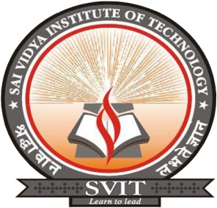

DEPARTMENT OF COMPUTER SCIENCE AND ENGINEERING
SAI VIDYA INSTITUTE OF TECHNOLOGY
(Affiliated to Visvesvaraya Technological University, Belagavi | Recognized by Govt. of Karnataka | Approved by AICTE, New Delhi)
Accredited by NBA, New Delhi
RAJANUKUNTE, BENGALURU – 560 064
2021-22
S

